2014 School Mental Health Surveys (SMHS)
Data Application

INSTRUCTIONS:
- Read Sections A (Expectations and Obligations) and B (Security Requirements) below.
- Fill out the appropriate forms and submit to the SMHS team:
  - Data Access Form (Form 1) to request access to the SMHS data.
  - Security Requirements Form (Form 2) to describe how your storage of the data will comply with the listed security requirements.
- Upon approval of the request, the SMHS team will contact you and provide you the following:
  - A Data Sharing Agreement to be signed by your university research offices/requesting institutions, to make the agreement legally binding. This Agreement will formally outline the expectations and obligations around data sharing that are described below in Sections A and B.
  - Instructions for receiving the data.
  - Suggestions for potential collaborations among the SMHS co-investigative team.
- Upon receipt of the signed Data Sharing Agreement, the SMHS team will transfer the requested data.

Section A: EXPECTATIONS & OBLIGATIONS
1. Maintaining Data Confidentiality
- You shall keep the data confidential, shall not disclose the data or share with unauthorized parties, and shall take all steps necessary to protect the data in accordance with the Security Requirements specified.
- You shall only release or publish aggregates that do not directly or indirectly identify any participants (i.e. students, teachers, principals, schools, or school boards).
- Each faculty, staff or student trainee who is granted access to the data is precluded from sharing it with others who have not been formally granted access through this same data sharing agreement process.

2. Use of the Data
- The data shall be used for statistical and research purposes only.

3. Intellectual Property and Use of Reports
- By transferring the data, no ownership rights in or to the data are being transferred.
- The SMHS team makes no assurances about the work(s) produced, and the use of this data does not imply endorsement by us.
- When using the SMHS data, please acknowledge our research project and applicable documentation in your reports, publications, or presentations. The acknowledgement to be used is the following:
This research uses data from the 2014 School Mental Health Surveys (http://www.ontariochildhealthstudy.ca/smhs), a project led by Kathy Georgiades and Michael Boyle at McMaster University and funded by the Canadian Institutes of Health Research (CIHR; www.cihr-irsc.gc.ca).
- We request that you provide us with copies and full citations of any publications, presentations, reports, etc., using our data. Please email us a full citation and a copy of the completed/published product to campom3@mcmaster.ca and georgik@mcmaster.ca.
Section B: SECURITY REQUIREMENTS

You are required to store the data and any associated work outputs/temporary files in a secure manner.

OPTION A: SECURE NETWORK DRIVE (PREFERRED OPTION)
For individuals with access to a secure network drive through their university or workplace, we request that you store your data on that drive. The location of the SMHS data on the network drive must only be accessible to you (i.e. not in a common folder). Accessing the data outside of your workplace through VPN access to the secure network drive is permissible as long as the data is not removed from the secure drive. Temporary files produced by statistical software programs must also be directed to be saved on the secure network drive (instructions provided below).

Screenshot of an SMHS data folder within a secure network drive:
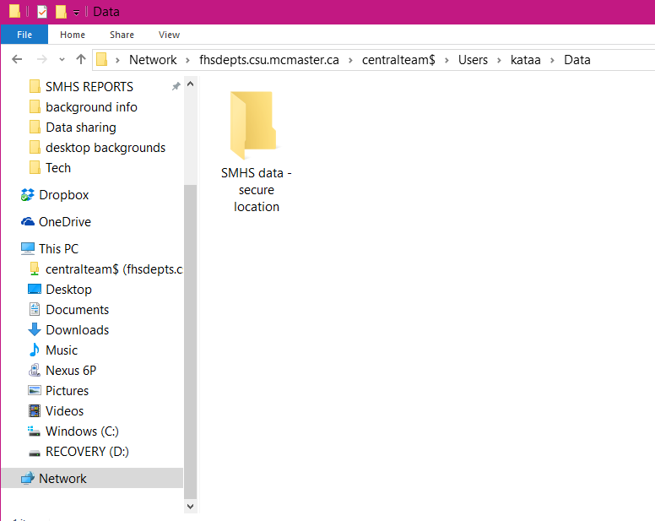

OPTION B: A DESIGNATED PASSWORD-PROTECTED COMPUTER
If a secure network drive is not available, the data may be stored on the hard drive of a designated computer that meets the following requirements:
- The designated device must be password-protected, and accessible only to the individual granted access to the data.
- Data should not be moved from that device onto any physical transportable media (e.g. USB key, CD-ROM), nor should the data be electronically transferred to other locations via unsecure methods such as email. All the data, output, and temporary files should be stored together in a designated folder.

INSTRUCTIONS TO REDIRECT TEMPORARY DATA FILES:
All temporary data and working files that are generated during the execution of various statistical software programs are to be directed and stored on the secure network drive (option A) or in the same password-protected folder described above (option B). The following are some popular statistical applications and directions for redirecting the temporary working directories:

Stata
- To point temporary Stata files to a secured directory, you need to set an environment variable called STATATMP and point it to the secured directory (i.e., e:\ahd\tmpSTATA).
- See http://www.stata.com/support/faqs/data/statatmp.html for more details.

SAS
- Add the following to the end of the "Target/Command" line in the properties of the SAS shortcut: -work "drive_letter:\secure_directory" (i.e.: -work "e:\ahd\tmpSAS").
- See http://www.ats.ucla.edu/stat/sas/icu/custom_win.htm for more details.

SPSS
- In SPSS you need to manually set the temporary working directory. This is done under Edit, Options, Temporary Directory.

Mplus
- Mplus uses intermediate files for controlling outputs. These files are created in the working directory. The working directory is usually the directory with the input file. There is one instance when it is not and that is when Mplus is first opened and the recent file list is used to open a previous input file. To ensure that the working directory is always the directory with the input file, always use the File -> Open/Save options for opening/saving an input file.
- Alternatively, to set Mplus to use a secured directory for temporary files, create the FORT_TMPDIR environment variable and assign it the name of the secured directory.

If you have any questions about these requirements, please contact the research team at campom3@mcmaster.ca or georgik@mcmaster.ca.

Form 1: DATA ACCESS FORM

PLEASE COMPLETE THE FIELDS BELOW AND SUBMIT THIS FORM WITH YOUR DATA APPLICATION REQUEST.

If data will be accessed/used by multiple researchers at a single location for multiple projects, each project requires its own individual data access form.

For student trainees applying for access, this form should be completed with their supervisor. In these cases, please ensure that the names and e-mail addresses of both the supervisor and trainee are specified below.

TITLE:
NAME:
INSTITUTION:
CORRESPONDENCE ADDRESS:
E-MAIL ADDRESS:
PHONE NUMBER:
FAX NUMBER:
(If applicable) STUDENT NAME:
STUDENT E-MAIL

Research project title:

Please describe the study rationale – how the research will contribute important, novel and/or useful information linked to policy or practice

Please specify the study objective(s):

Please specify the research question(s):

Please identify the core study concepts and variables – i.e. dependent and independent variables, covariates:

Briefly describe the statistical analyses that will be conducted and the proposed software that will be used:

Specify which data files are being requested and the rationale for the request in relation to your research objectives:
Student file. Specify rationale:

Teacher file. Specify rationale:

Principal file. Specify rationale:

School aggregate file:

Please specify the product(s) that will be produced – i.e. manuscript submitted for peer-review to an academic journal, presentation at a conference or meeting, report for stakeholder(s), undergraduate thesis, Master’s thesis, PhD thesis, paper for a course, etc.:

Please specify the anticipated timelines for completion of the project (month/yyyy):
Analysis completed by:

Draft of product completed and circulated for review by colleagues/collaborators by:

Final product submitted/completed by:

- Please list the names of any research assistants/coordinators, colleagues, or other employees who will be accessing these data under your supervision for the project described herein:

(Using the data for a separate project requires a new Data Access Form.)

Form 2: SECURITY REQUIREMENTS FORM

PLEASE COMPLETE THE FIELDS BELOW TO ENSURE THAT ALL THE SECURITY REQUIREMENTS ARE MET AND SUBMIT THIS FORM WITH YOUR DATA APPLICATION REQUEST.

Questions 1-7 must be answered. Questions 1 a)-c) are only to be completed if selecting Option A; questions 1 d)-g) are only to be completed if selecting Option B.

Data Storage:
- Please specify which storage arrangements you will be using for the data:

Option A) Secure network drive (option preferred by the SMHS team)
If option A, please complete 1 a) to c):
- Who is offering the secure network drive (i.e. University, workplace)?

- Do you have your own user area that others cannot access? If NO, specify what actions may be put in place to protect these files from being accessed by unauthorized users.

- Is this drive accessible via VPN?

Option B) Password-protected folder on a DESIGNATED password-protected computer
If option B, please complete 1 d) to g):
- Specify the device type (i.e. desktop, laptop), make and model:

- The designated password-protected computer used to access the data is only accessible to the person granted access to the data – i.e. it should not be a shared device.
Implemented Not implemented (explain why not)

- The computer used to access the data is password-protected. The password should be strong – i.e. a minimum eight-character password with combination of numbers, symbols and mixed-case letters. A password generator can be found here: http://passwordsgenerator.net/
Implemented Not implemented (explain why not)

- Data should not leave the original designated secure location. For individuals using Option A specified above, data should not be removed from a network drive and saved on a hard drive or transportable media. For individuals using Option B specified above, data should not be moved from the designated folder on the hard drive and saved onto transportable media.
Implemented Not implemented (explain why not)

- I have configured my statistical software to point temporary files to save in the secure location (instructions provided above).
Implemented Not implemented (explain why not)

Physical storage:
- Any printed documents containing information should be stored in secure containers (e.g. locked drawers, filing cabinets) when not in use.
Implemented Not implemented (explain why not)

- Printed materials containing data must be destroyed (shredded) in a secure manner before disposal.
Implemented Not implemented (explain why not)

Data retention:
- An annual review will occur to ensure data storage requirements are being followed.
Implemented Not implemented (explain why not)

- All data files must be deleted once work has been completed; output and syntax files may be kept. There will be a grace period of 1 year following a publication to allow any queries about the data to be answered.
Implemented Not implemented (explain why not)

If changes are made to the storage situation described above, please inform the SMHS team.

In requesting use of the SMHS data, I will agree to the following conditions:
- I agree to follow the security requirements specified in Section B of this agreement.
- I agree NOT to identify any individual participants (i.e. students, teachers, principals, schools, or school boards) or to attempt to compromise the anonymity of the entries in the data files.
- I agree to cite the SMHS dataset and applicable documentation appropriately.
- I agree to provide the McMaster research team with the citations and copies of publications, presentations, and reports I produce using these data.
- I agree NOT to give data to any third party.
- I agree that the SMHS research team makes no assurances about the work(s) produced, and the use of this data should not imply endorsement by the SMHS team.

By signing this agreement, I am acknowledging that I have read, understood, and agree to comply with the terms and conditions above:
Please sign here |  | Date
Print name here
Please scan the completed forms (Forms 1 and 2) and email to campom3@mcmaster.ca or georgik@mcmaster.ca.

FOR OFFICE USE ONLY:
APPLICATION APPROVED: Yes No PROJECT NUMBER: ____________________
APPROVAL DATE: ____________________

